**Changes Related to Design**

**23 Minor Changes:**

1. **Missing Curriculum Vitae (CV) Section**
2. Add a CV section to the website for individuals seeking employment.
3. Include subsections for job seekers, internships, and apprenticeships for young people learning trades from professionals.
4. **Activity Selection**
5. Implement a feature allowing users to select the type of professional they are seeking (e.g., plumber, electrician, painter, accountant, secretary).
6. **Professional Authorization (Kbis)**
7. Add a requirement for professionals to provide a Kbis document, which is the authorization to work in France.
8. Include fields for civil liability and ten-year insurance.
9. **Welcome Photo (Homepage or Landing Page)**
10. Replace the photo of the two doctors on the welcome page.
11. Use a photo of a mechanic and a painter instead, as doctors will not register as job seekers on the platform.

Instead Include like this one:

1. A group of people posing for a photo

   Description automatically generated
2. **Professional Rates**
3. Allow professionals to set their rates either by the hour or by the day.
4. Add an option for a package rate (daily package) and a customizable package on estimate.
5. **Copy Profile Page**
6. There should be an option on the profile to “share” the profile or page through its link.

(A Link will be shown of that specific Profile or Page and under that a “Copy Link” Option will copy the Profile or Page Link).

1. **Messages (Inbox) Filter Option**
2. There should be an option in the “Message” page to filter up the messages by: toutes les conversations(all conversations), Non lues(unread), mes demandes(my requests), mes offres(my offers).

1. **Home Button Label**
2. Change the label for the "Home" button from "maison" to "accueil" in French.
3. **Availability Button**
4. Add an "On/Off" button to indicate the availability of professionals.
5. Include an emergency button for immediate availability.
6. **Additional Sections**
7. Destocking Section: Include a section for stores selling equipment at a discount.
8. Training Section: Add a section for training programs.
9. Franchise Section: Create a section for businesses looking to franchise in other cities.
10. **B2B Job Listings**
11. the B2B job section to improve graphical elements, specifically changing the graphic that includes a phone with payment transactions.

***(At this point, he’s talking about this:***

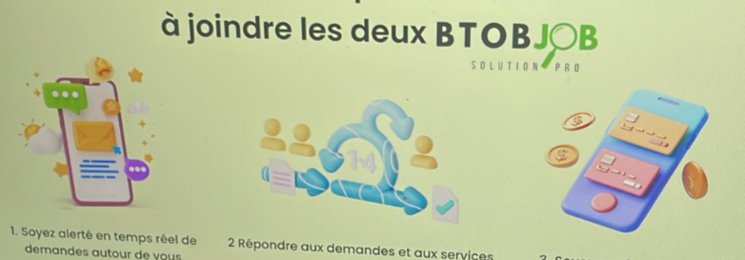

***Change it to like these:***

,

***Include graphical elements that are more realistic and modern than this picture’s elements, as the concept is to promote the Professionals and Businesses to Businesses or Professionals on the website).***

1. Note that the platform only handles subscription payments for professionals and does not take a percentage from transactions between users – (Technical Element – Development Purpose).

*Overall Additional Modifications:*

*Review and implement 23 minor modifications as detailed.*